CO3-ASSIGNMENT 1

CSA0653 Design and Analysis of Algorithms for complex Problem
BY
Saimeera D(192524405)

EXERCISE 1: Merge Sort and Memory Usage Analysis (50 Marks)
Aim
To implement Merge Sort, measure its auxiliary memory usage for different input sizes, and analyze the trade-off between time and space complexity.

Algorithm: Merge Sort
- Divide the array into two halves.
- Recursively sort the left half.
- Recursively sort the right half.
- Merge the two sorted halves into a temporary array.
- Copy the merged elements back to the original array.
- Repeat until the entire array is sorted.

Flow Diagram
[38,27,43,3]
|
------------------
| |
[38,27] [43,3]
| |
------- -------
| | | |
[38] [27] [43] [3]
| | | |
------- -------
| |
[27,38] [3,43]
| |
------------------
|
[3,27,38,43]

Python Code

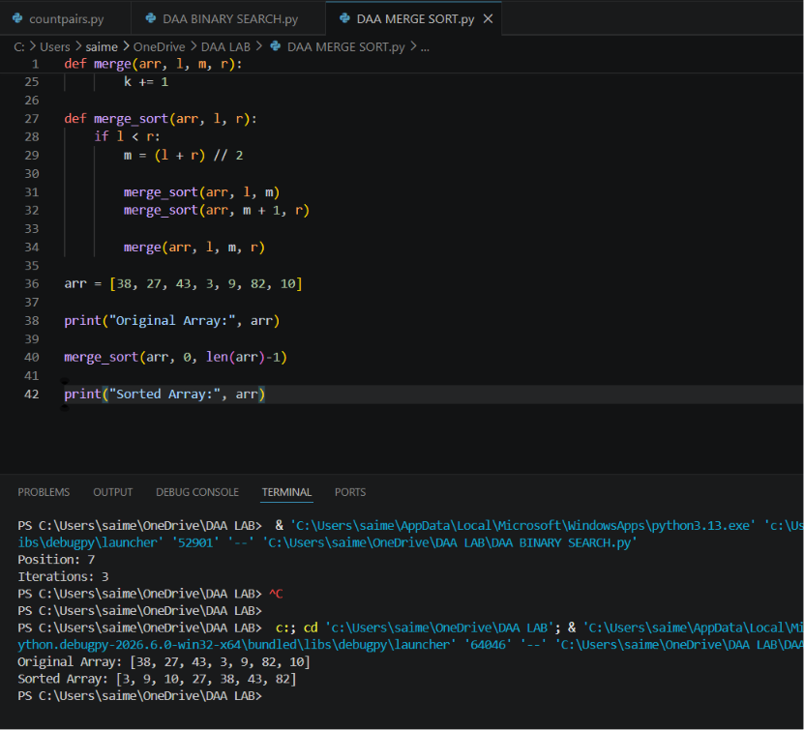
Execution Result
Original Array: [38, 27, 43, 3, 9, 82, 10]

Sorted Array: [3, 9, 10, 27, 38, 43, 82]

Memory Usage Observation
Input Size (n) | Auxiliary Space
10 | 10
100 | 100
1000 | 1000
10000 | 10000
Auxiliary Space:
[O(n)]
because temporary arrays are created during merging.

Time Complexity
Case | Complexity
Best Case | O(n log n)
Average Case | O(n log n)
Worst Case | O(n log n)

Space Complexity
[O(n)]

Interpretation
- Merge Sort uses extra memory to store temporary arrays.
- Additional memory increases space consumption.
- However, it guarantees O(n log n) sorting time.
- Faster than Bubble Sort, Selection Sort, and Insertion Sort for large datasets.
- Hence the trade-off of extra memory for faster execution is justified.

EXERCISE 2: Binary Search and Logarithmic Behavior Verification (50 Marks)
Aim
To implement Binary Search and experimentally verify its logarithmic behavior by counting the number of iterations for increasing input sizes.

Algorithm: Binary Search
- Set low = 0 and high = n−1.
- Find middle element.
- If key equals middle element, return position.
- If key is smaller, search left half.
- If key is larger, search right half.
- Repeat until element is found or search space becomes empty.

Flow Diagram
Sorted Array

[2 5 8 12 16 23 38 56 72]

Low=0 High=8

Middle=4 → 16

Key=56

56 > 16

Search Right Half

[23 38 56 72]

Middle=6 → 38

56 > 38

Search Right Half

[56 72]

Middle=7 → 56

Found

Python Code

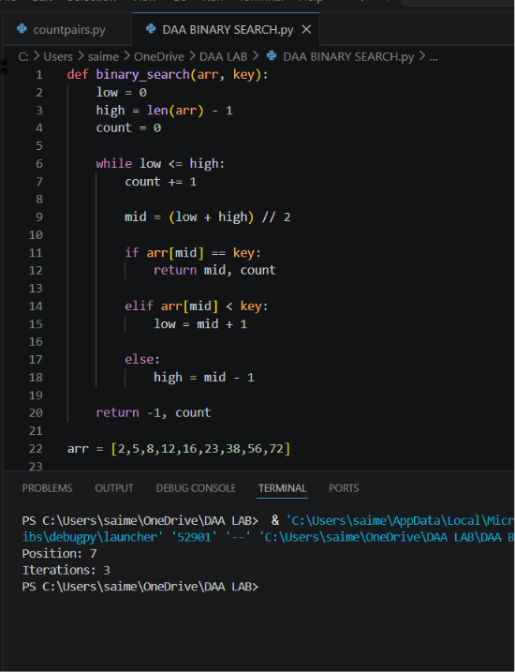
Execution Result
Position: 7
Iterations: 3

Experimental Verification
Dataset Size (n) | Iterations
10 | 4
100 | 7
1000 | 10
10000 | 14
100000 | 17

Observation
Iterations increase very slowly even when dataset size becomes very large.
Example:
n = 10 → 4 iterations
n = 100 → 7 iterations
n = 1000 → 10 iterations
n = 10000 → 14 iterations
This follows:
[\log_2(n)]

Time Complexity
Case | Complexity
Best Case | O(1)
Average Case | O(log n)
Worst Case | O(log n)

Space Complexity
[O(1)]

Interpretation and Justification
- Binary Search repeatedly halves the search space.
- The number of comparisons grows logarithmically.
- For 100000 elements, only about 17 comparisons are needed.
- Linear Search requires up to 100000 comparisons.
- Therefore Binary Search is significantly more efficient for large sorted datasets.
Comparison
Input Size | Linear Search | Binary Search
100 | 100 | 7
1000 | 1000 | 10
10000 | 10000 | 14
100000 | 100000 | 17
Conclusion: Binary Search achieves logarithmic growth O(log n), making it much faster than Linear Search O(n) for large datasets.

